II B. Tech. I Semester Regular Examinations – December, 2022
OBJECT ORIENTED PROGRAMMING THROUGH JAVA
(CSE/CSE(CS)/CSE(AIML))
Time: 150 Min Max. Marks: 80M

SECTION – A
Answer all Four questions 4×10M=40M
- There are x mice and x holes placed in a straight line. Each hole can accommodate only 1 mouse. The position of the mouse is such that it can stay at his position or move towards right one step from x to x + 1, or move towards left one step from x to x - 1. It takes only 1 minute to follow any of these moves. Design and develop a solution that assigns mice to holes so that the time when the last mouse gets inside a hole is minimized.

- A password is considered strong if the below conditions are all met:
- It has at least 6 characters and at most 20 characters.
- It contains at least one lowercase letter, at least one uppercase letter, and at least one digit.
- It does not contain three repeating characters in a row (i.e., "Baaabb0" is weak, but "Baaba0" is strong).
Given a string password, Design and develop a STRONGPASSWORD class with method that returns the minimum number of steps required to make password strong. if password is already strong, return 0.
In one step, you can:
- Insert one character to password,
- Delete one character from password, or
- Replace one character of password with another character.

- Given a string containing digits from 2-9 inclusive, Design and create a class with methods that return all possible letter combinations that the number could represent. Return the answer in any order.
A mapping of digits to letters (just like on the telephone buttons) is given below. Note that 1 does not map to any letters.
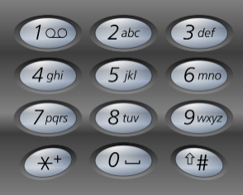
Input: digits = "23"
Output: ["ad","ae","af","bd","be","bf","cd","ce","cf"]

- Design and create a class for a Least Frequently Used (LFU) cache.
Implement the LFUCache class:
- LFUCache(int capacity) Initializes the object with the capacity of the data structure.
- intget(int key) Gets the value of the key if the key exists in the cache. Otherwise, returns -1.
- void put(int key, int value) Update the value of the key if present, or inserts the key if not already present. When the cache reaches its capacity, it should invalidate and remove the least frequently used key before inserting a new item. For this problem, when there is a tie (i.e., two or more keys with the same frequency), the least recently used key would be invalidated.
To determine the least frequently used key, a use counter is maintained for each key in the cache. The key with the smallest use counter is the least frequently used key.
When a key is first inserted into the cache, its use counter is set to 1 (due to the put operation). The use counter for a key in the cache is incremented either a get or put operation is called on it.
SECTION - B
Answer all Two Questions 2 X 20M=40 M
- Generate tabbed panes for computation of income taxes. In the last pane the total income tax computation should be shown. The tax slabs are
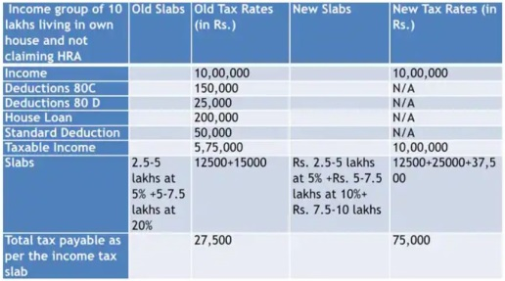
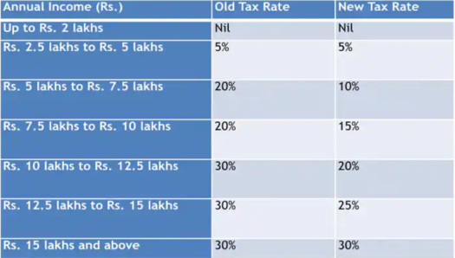

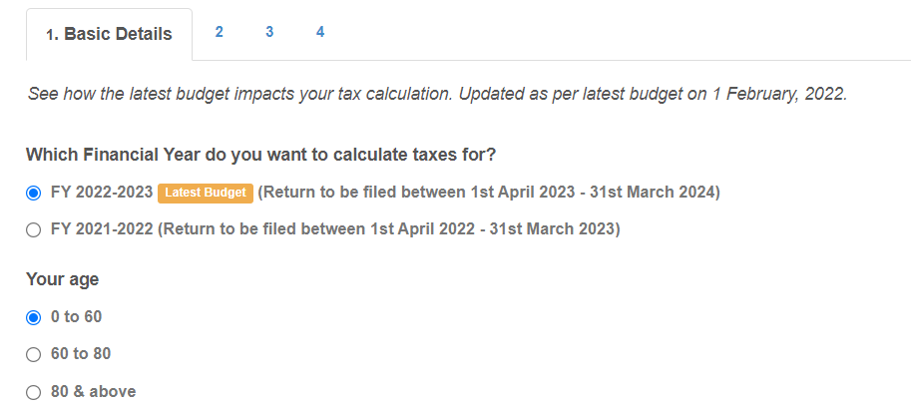
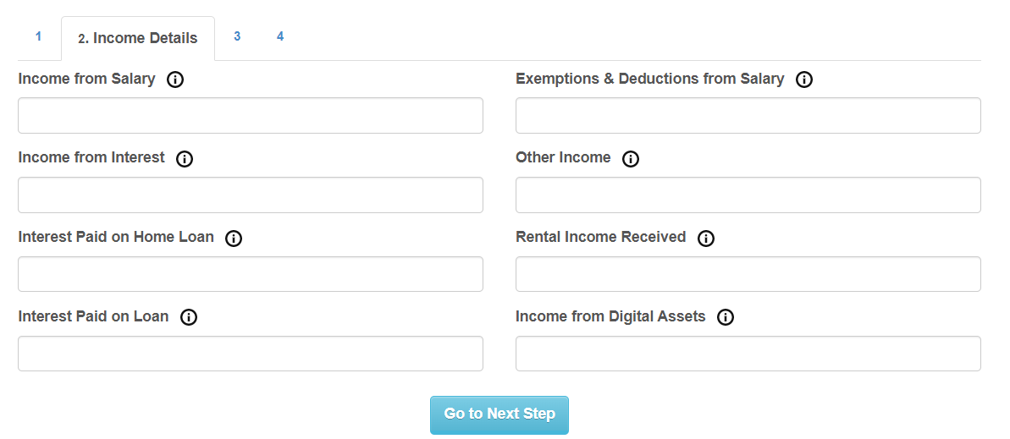
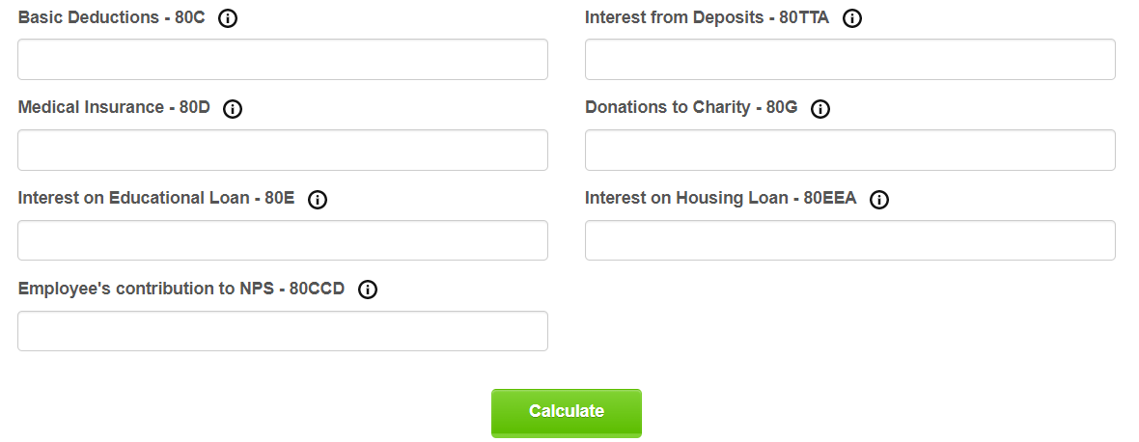

- For a given array [5, 1, 9, 0, 2, 8, 7], create two classes using Java, one implementing insertion sort and the other performing binary search. It is already known that Insertion Sort creates a sorted array iteratively i.e., positioning the current element in its proper place one step at a time. In your code use the Binary Search Algorithm to find the new position of current element. Also, find the computation time if current location detection using general and binary search technique.

